**Experimental Analysis of Steam Turbine**

Christopher R. White

MWG: David Bedding, Jorge Godoy, Samuel Hordeski, Kevin Myers, Justin Sandler

Department of Mechanical Engineering

Lafayette College

Easton, PA 18042

**Abstract**

Power plants must have sufficient capacity to supply the anticipated daily peaks in the varying aggregate electricity demand of the commercial, residential, industrial, and agricultural sectors. The majority of power is produced by electric generators driven by steam turbines, which are devices that extract kinematic energy from superheated steam as it flows from high to low regions of temperature and pressure. The performance of a steam turbine is dependent on the design and thermal properties can be evaluated using thermodynamic analysis of the Rankine cycle. The purpose of this experiment was to determine the optimal load for the **maximum thermal efficiency** of a 5 kW Carling “A Series,” single-stage, impulse type turbine. Resistive loads between 0 and 100 light bulbs were applied on the turbine output shaft via generator while measuring temperature, pressure, and mass flow rate at states located between components. The lightbulbs were used to explore the effect of load on t**hermal efficiency** between resulting in a _______ trend with thermal effiecnyies of __±__ and __±__ respectively. Based on thermal efficiency, the optimal loading for maximum efficiency was _______. The 3 operating conditions studied in this study were ___, 60, and _____ had these efficiencies at ____ rpm. The condenser effectiveness was _______. Pefformance limiting characteristics of cycle **554**

**Introduction and Methods**

The U.S. Energy Information predicts that energy use will increase by 29% from 2012 to 2040, increasing from 3,826 billion kWh to 4,4954 billion kWh [1]. While this is roughly increasing by 0.9%/year, as the world’s resources contine to depelete, efficient power generation has both environmental and economic incentives[1]. **in order to produce more work, either more energy can easily be put into the system, or a more efficient turbin can be used since** according to the law of conservation of energy, you cant etract more enegery than you put into it. Testing the effects of various loadings is important expecially because of the varying energy demand throughout the day, turbine manufacturerers want to test the performance of their products to suit their customers needs. Study using the steady-flow energy equation per unit mass of steam. Using the ideal Rankine cyclic the thermal efficiency of the ideal and actual Rankine cycles were determined. The Rankine cycle operates on a working fluid which is water and it follows is a closed loop and is reused. Assuming that all 4 components of the **Rankine cycle** illustrated in Fig.1 are steady-flow devices, small changes in kinetic and potential energy relative to the work and heat transer are negligible then each of the dvices can be  **can be analyzed** using the steady-flow energy equation, expressed as

${(q}_{in}-q_{out})-{(w}_{in}-w_{out})= h_{e}-h_{i}$ (kJ/kg) ⑴

where $q$ is heat transfer and $w$ is the work into and out of the system, and $h$ are is the enthalpy at the exit and inlet of the control volume.

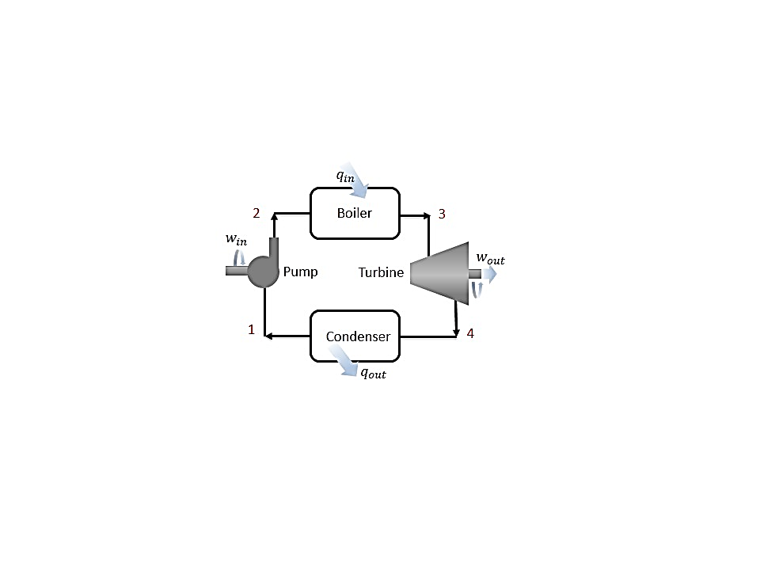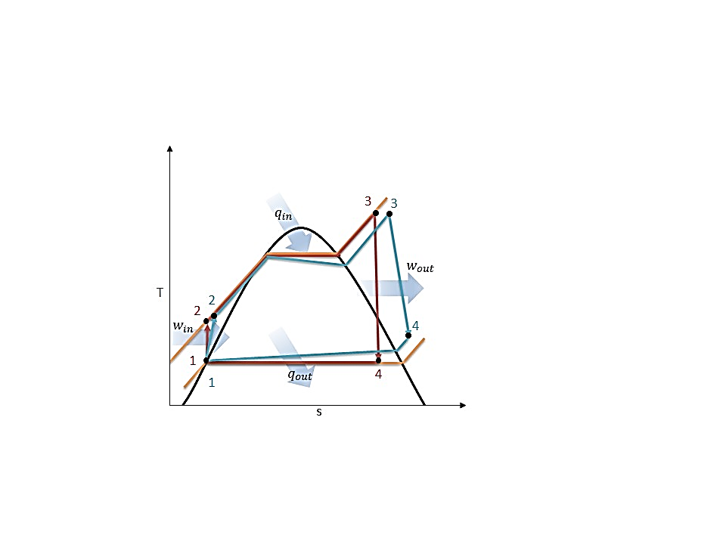

**Figure 1: (a) Schematic, and (b) Temperature-Entropy Diagram for Ideal (red) and Actual (blue) Rankine Cycle, [2] Replicated by White C.**

The ideal Rankine cycle begins with saturated liquid entering the pump at state 1, where work is applied to compress the water isentropically to the pressure of the boiler illustrated in Fig. 1. Since pump work is an isentropic process assuming no heat transfer, it is expressed as

$w_{pump,in}= h_{2}- h_{1}$ (kJ/kg) ⑵

where $w_{pump,in}$ is the pump work applied on system and $h$ is the enthalpy at the entrance and exit of the pump. Upon exiting the pump, the compressed liquid enters the boiler at stage 2, which heats the water isobarically to a superheated vapor via combustion or nuclear reactors. Since no work is applied during the heating procces, the heat transfer is expressed as

$q_{in}= h_{3}-h_{2}$ (kJ/kg) ⑶

where ${ q}_{in}$ is the heat transferred into the water, and $h$ is the enthalpy at the entrance and exit of the boiler. The superheated vapor enters the steam turbine at stage 3 where it undergoes a pressure drop isenthalpically as the steam prduces work by rotating the shaft connected to a generator. Using Eq. (1), the work produced is expressed as

$w_{turb,out}= h_{3}- h_{4}$ (kJ/kg) ⑷

where $w_{turb,out}$ is the work produced by the steam, and $h$ is the enthalpy at the entrance and exit of the turbine. The pressure and the temperature of of the steam drops until it leaves the turbine and enters the condenser as a high quality mixture. The high pressure and temperature stem is converted into kinetic energy through a nozzle that is aimed at the turbine blades. Within the condenser, heat is exchanged betweem the condensing steam and cold water. Assuming _____, the heat transfer from the system is expressed as

$q_{out}= h_{4}-h_{1}$ (kJ/kg) ⑶

where $q_{out}$ is the heat transferred into the cooling water, $\dot{m}$ is and $h$ is the enthalpy at each state. The steam is condensed until a saturated liquid where it enters the pump completeing the cycle. A condensate pump may be used to lower the condenser pressure, increasing the pressure drop across the turbine resulting in greater work output. Using the conservation of energy relation, the performance of the cycle is characterized by the thermal efficiency, which is the ratio between the net work and heat transfer within the boiler and is expressed as

$η_{th}=\frac{w_{net}}{q_{in}}=\frac{w_{turb,out}-w_{pump}}{q_{in}}$ ⑸

where $Q_{in}$ and $W_{net,in}$ are determined using Eq. (2), Eq. (3), and Eq. (4).

The actual vapor power cycle is different from the ideal Rankine cycle as illustrated in Fig. 1 as the result of irreversabilities in each component. Fluid friction and heat loss to surroundings are the primary sources of irreversabilities. Fluid friction causes pressure drops within the boilier, condenser, and piping.

It the performance of a turbine is determined using the isentropic efficiency, which compares the performance of the actual turbine to the performace achieved by an ideal isentropic turbine. Heat lost is assumet o be negligible. The starting pressure and temperatue is the same at the entrance of the both the ideal and actual turbines.

**CoP is significantly influenced by the mass flow rate of the refrigerant, which is controlled by the throttling valve. The TEV, CT, and HEV are unique designs that control the flow rate with different physical mechanisms resulting in dissimilar CoP values due to the variation in pressure drops.**

In the current study, the actual CoP was experimentally determined for 3 throttling valves and compared to the theoretical CoP in order to determine the optimal valve for the VCR cycle.

The experiments were performed on the Hampden Refrigeration Trainer, by running the cycle in forward mode while monitoring temperature, pressure, and mass flow rate at specific points in the cycle. The actual CoP was experimentally determined for the TEV, CT, and HEV control by using the first law of thermodynamics. The locations of the instrumentation are displayed on a schematic of the actual VCR cycle in Figure 2.

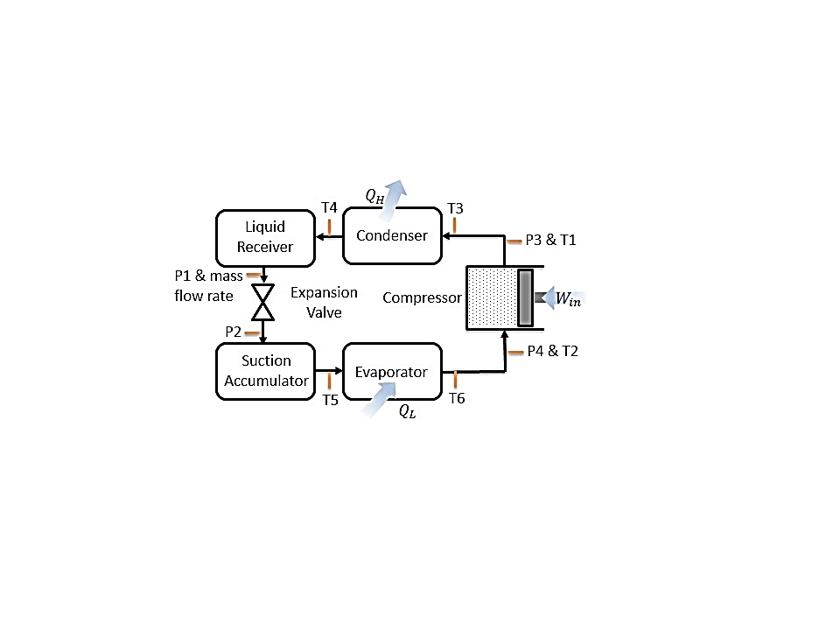**Results and Discussion**

**Figure 2: Hampden Refrigeration Trainer Schematic with Instrumentation Locations: Type-T Thermocouples, Sho-Rate "50" Model 1350E Flow meter, and Pressure Transducers [White C.]**

Three experimental set ups were considered: (1) Cooling (FWD) mode with TEV control, (2) Cooling (FWD) mode with CT control, and (3) Cooling (FWD) mode with HEV control at mass flow rates between 1.86 – 4.77 g/s.

For the TEV control arrangement, the system was prepared according to the startup procedure in the Operating Instructions at a laboratory temperature of 24˚C [3]. Temperature, pressure, and mass flow rate were measured at the locations displayed in Figure 2. Each measurement was recorded 3 times in intervals of 5 minutes in order to confirm that the system had reached steady state as gauge fluxuations were minimal. At a mass flow rate of 3.62±0.363 g/s, the actual CoP for TEV control was 2.26±0.09 determined using Eq. (5) displayed in Figure 3.

The effects of CT control was set up by opening the CTV and closing the TEV-1 in Figure 2. Temperature, pressure, and mass flow rate were measured 3 times at the locations displayed in Figure 2. At a mass flow rate of 4.31±0.362 g/s, the actual CoP for CT control was 2.10±0.09 determined using Eq. (5) displayed in Figure 3.

HEV control was established by slightly cracking the HEV and closing the CTV and the system was tested by adjusting the HEV to produce flow rates of 1.86±0.364, 3.39±0.363, and 4.77±0.362 g/s. Temperature, pressure, and mass flow rate were measured at the locations displayed in Figure 2 at each flow rate. The actual HEV CoP values for each flow rate were 3.04±0.13, 2.63±0.11, and 1.62±0.06 respectfully determined using Eq. (5) displayed in Figure 3.



**Figure 3: (a) Pressure-Enthalpy and (b) Temperature-Entropy Diagrams for Ideal (red) and Actual (blue) VCR Cycle Processed in MATLAB with CoolProps  
AT**

While the VCR cycle is a realistic model of the actual cycle, there are differences between 3 of the stages due irreverabilities occurring throughout the refrigeration system. The two significant sources of irreversabilites are piping losses and unwanted heat transfer with the environment, the effects of which are displayed in Figure 3. Piping losses have a minimal effect on the cycle occurring in the condenser (stages 3 to 4) and the evaporator (stages 7 to 8.) They are a result of fluid friction against the inner surface of the piping and components under the no slip boundary condition. Within both the condenser and evaporator, heat lost and gained increases with respect to mass flow as shown in Table 1.The most significant source of irreversibility occurs in the compression process due to entropy generation from friction between the vapor and the interior of the pump. Unlike the ideal isentropic process, the actual VCR cycle compressor significantly increases temperature of the vapor resulting in entropy generation due to the friction and heat transfer. In Table 1, compressor efficiency increased with mass flow rate, with the exception of the HEV at 4.77g/s, which was due to the high vapor mass flow forcing the compressor to apply significantly more work resulting in a low efficiency in comparison to the ideal compression process.

**Table 1: VCR Mass Flow Rate, Heat Lost, Heat Gained, and Compressor Efficiency for Each Expansion Valve**

|  |  |  |  |  |  |  |  |  |
| --- | --- | --- | --- | --- | --- | --- | --- | --- |
|  | Mass Flow Rate | | | Heat Lost (W) | Heat Gained (W) | Compressor Efficiency | | |
| HEV1 | 1.86 | ± | 0.364 | 304.3 | 404.4 | 0.120 | ± | 0.0188 |
| HEV2 | 3.39 | ± | 0.363 | 500.0 | 690.4 | 0.211 | ± | 0.0174 |
| TEV | 3.62 | ± | 0.363 | 504.2 | 727.3 | 0.292 | ± | 0.0154 |
| CT | 4.31 | ± | 0.362 | 548.0 | 809.0 | 0.453 | ± | 0.0165 |
| HEV3 | 4.77 | ± | 0.362 | 607.9 | 984.2 | 0.333 | ± | 0.0124 |

Furthermore in the ideal cycle, refrigerant leaves the evaporator as a saturated vapor and enters the compressor as a saturated vapor, whereas in the actual cycle, the refrigerant may degrade in quality, resulting in condensation entering and damaging the compressor. Therefore actual refrigeration systems add a few extra degrees of super heat to the refrigerant in the evaporator in order to superheat the refrigerant vapor to ensure that the refrigerant is fully vaporized throughout the compression process [2]. In addition to the superheating process, a component called a suction accumulator, located between stages 8 and 1, ensures that no condensed liquid enters the compressor by separating the condensed liquid from the vapor. Accumulators have a metering ejector device that vaporizes the liquid built up in a reservoir.

In addition, refrigerant enters the expansion valve as a saturated liquid in the ideal system after leaving the condenser, however this may not be the case in the actual cycle due to the pressure drop between stages 3 and 4 due piping losses from friction resulting in left over vapor. It is undesirable to have a mixture entering the throttling valve, because of the lower entry enthalpy, therefore the refrigerant passes through the liquid receiver at stages 4 to 5, ensuring that only a saturated liquid enters the valve. It serves as a seal against the entrance of vapor refrigerant entering the liquid line by accumulating liquid refrigerant and ensures the availability of stored refrigerant until the system requires it.

Irreverabilitieshave a negative effect on refrigerator performance and therefore the actual CoP is less than the ideal CoP. The primary source of this decrease is due to the entropy generation within the compressor in the actual cycle. It was observed that ideal CoP increases with respect to mass flow rate according to Eq. (5), since the refrigerant enters the compressor as soon as it reaches the saturated vapor line, resulting in a small heat lost region in Figure 3. When compared to the actual cycle which has a much greater heat lost region, CoP decreases because the heat transfer is similar to the value of thecompressor work based on Eq. (5).While the ideal and actual CoP values may behave differently, it is a result of the entropy generation within the compressor that is not accounted for in isentropic process in the ideal cycle. Despite the irreversibilities occurring in the compressor, the ideal VCR cycle is a valid model for the actual cycle due since error bars of the actual CoP values are insignificant in Figure 4.

**Figure 4: Actual and Ideal VCR Cycle CoP for Each Expansion Valve**



According to Figure 4, HEV control at a flow rate of 1.86 g/s results in a high CoP, however the system may need to run through multiple cycles to achieve the same heat transfer produced at higher mass flow rates due to the low compressor efficiency in Table 1. At high flow rates of 4.77 g/s, HEV control provides a high heat transfer, however the compressor efficiency diminishes due to the high amount of work required to operate the compressor. The results from the 3 HEV experiments displayed a decreasing linear relationship between the actual CoP and mass flow rate. As mass flow rate decreases, cooling power decreases, requiring less compressor work thus increasing CoP. Lower compressor work is the result of the refrigerant entering the compressor at a higher super-heated vapor since the refrigerant enters the vaporizer at a very small mass flow rate. This increases the enthalpy and temperature of the superheated vapor at the beginning of the compression making the compressor work less due to the small difference in enthalpies using Eq. (2). The low mass flow rate means that the refrigerant is capable of absorbing heat at the evaporator and dispersing heat at the condenser occurs relatively easily and but inefficiently.Higher mass flow rate results in not all of the refrigerant absorbing heat in the evaporator quickly, and results in higher efficiency until 4.77 g/s.

HEV1 resulted in compressor entrance and exit temperatures of 299.3 K and 369.8 K with expansion tube entry and exit temperatures of 314.8 K and 269.2 K and was significantly different from the behavior found in the TEV and CT. HEV2 displayed compressor entrance and exit temperatures of 297K and 370.4K and behaved similarly to the TEV. HEV3 had compressor entrance and exit temperatures of 283.7K and 379.8K and behaved similarly to the CT.While the HEV achieved the highest CoP, it simply is not suitable in a situation where the equipment would not be continuously adjusted for the optimal CoP based on environment temperatures, which would affect the heat transfer rates in the evaporator and condenser.

TEV control essentially forces the system to operate at equilibrium based on the refrigerant temperature at the exit of the evaporator. It had compressor entrance and exit temperatures of 290.4 K and 369.8K and resulted in a CoP that is slightly higher than that of CP control. This is due to the mechanics of TEV control, because flow rate is controlled through a mechanical feedback loop based on the refrigerant temperature at the evaporator exit. Therefore the valve adjusts to achieve the steady state mass flow rate of the refrigerant based on the temperature of the system. The TEV is an expensive, self-regulating expansion valve that is most suitable in a commercial environment with heavy duty HVAC systems. It has a compressor efficiency of 0.292±0.0154 based on Table 1.

CT control forces the system to operate based on the geometry of the tube and results in a compressor entrance temperature of 282 K due to a decrease in temperature through the suction accumulator. CT control had a compressor exit temperature of 362K. The decrease in temperature was due to the heat transfer with the environment due to the large surface area of the coiled tubes. The CT is a cheap, compact, and reliable expansion valve that is most suitable in a residential environment with small refrigeration systems. It has a higher compressor efficiency than TEV control of 0.453±0.0165 based on Table 1.

**Conclusions**

The purpose of this experiment was characterize the performance of the refrigeration system by determining the effect of TEV, CT, and HEV control on the VCR cycle. Though the first law of thermodynamics, the CoP was determined for the actual and ideal cycles for each expansion valve. The CoP error bars for the expansion valves in the actual cycle were minimal and therefore the VCR ideal model was accurate for modeling the actual cycle, even though the ideal model is different during the isentropic compression process. Based on the experiments it was determined that HEV control was the optimal control device due to its high CoP, but low compressor efficiency at low flow rates. Based on the HEV experiments, it was determined that TEV control was optimal for commercial refrigeration with a CoP of 2.26±0.09 and compressor efficiency of 0.292±0.0154. Whereas due to the compact size and low cost of the CT, it was best suited for use in residential refrigeration systems with a CoP of 2.10±0.09 and compressor efficiency of 0.453±0.0165.

**References**

1. U.S. Energy Information Administration - EIA - Independent Statistics and Analysis. (n.d.). Retrieved March 10, 2015, from http://www.eia.gov/forecasts/aeo/MT_electric.cfm
2. Ҫengel, T.A. and Boles, M.A. (2002) *Thermodynamics: An Engineering Approach,* McGraw Hill, 4th Edition.
3. Rossmann, T., Sabatino, D. & Utter B. (2015). *ME 475: Refrigeration System Laboratory Description*. Easton, PA: Lafayette College.

depends on the **In order to be an efficient generation plant operating at optimum efficiency, the study of thermodynamics is essential in the design and optimization of steam turbine systems, since the design and working fluid thermal properties have a significant effect on turbine performance.**

The efficiency of the Rankine cycle is limited by the high heat of vaporization of the working fluid. Also, unless the pressure and temperature reach [super critical](http://en.wikipedia.org/wiki/Supercritical_fluid) levels in the steam boiler, the temperature range the cycle can operate over is quite small: steam turbine entry temperatures are typically around 565°C and steam condenser temperatures are around 30°C. This gives a theoretical maximum [Carnot efficiency](http://en.wikipedia.org/wiki/Carnot_efficiency) for the steam turbine alone of about 63% compared with an actual overall thermal efficiency of up to 42% for a modern coal-fired power station. This low steam turbine entry temperature (compared to a [gas turbine](http://en.wikipedia.org/wiki/Gas_turbine)) is why the Rankine (steam) cycle is often used as a bottoming cycle to recover otherwise rejected heat in [combined-cycle gas turbine](http://en.wikipedia.org/wiki/Combined_cycle) power stations.